Experiment 25

Aim:

To Write a Python program to plot two or more lines with legends, different widths and colors.

Code :

import matplotlib.pyplot as plt

x = [1, 2, 3, 4, 5]

y1 = [1, 4, 9, 16, 25]

y2 = [2, 5, 8, 11, 14]

plt.plot(x, y1, label='Line 1', color='red', linewidth=2)

plt.plot(x, y2, label='Line 2', color='blue', linewidth=4)

plt.legend()

plt.title('Multiple Lines Plot')

plt.xlabel('X')

plt.ylabel('Y')

plt.show()

Output:

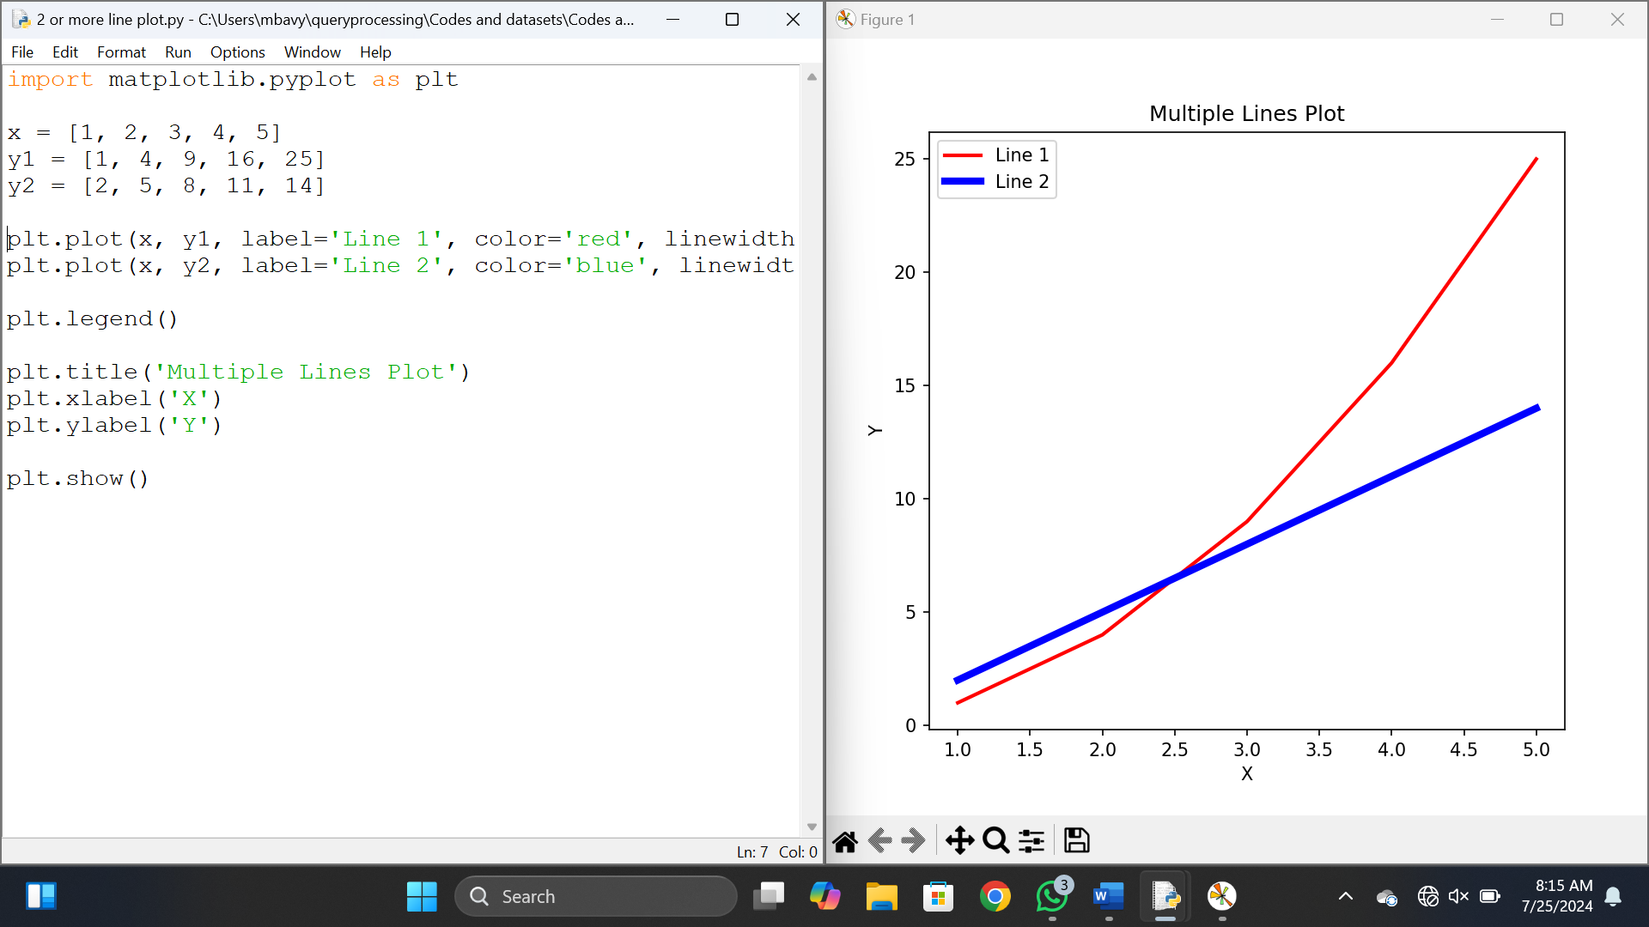

Results :

Thus a Python program to plot two or more lines with legends, different widths and colors is done.

Experiment 26

Aim:

To Write a Python program to create multiple plots.

Code :

import matplotlib.pyplot as plt

import numpy as np

x = np.linspace(0, 10, 100)

y1 = np.sin(x)

y2 = np.cos(x)

y3 = np.tan(x)

fig, axs = plt.subplots(2, 2, gridspec_kw={'height_ratios': [2, 1], 'width_ratios': [1, 1]})

axs[0, 0].plot(x, y1)

axs[0, 0].set_title('Sin(x)')

axs[0, 1].axis('off') # Empty subplot for top right

axs[1, 0].plot(x, y2)

axs[1, 0].set_title('Cos(x)')

axs[1, 1].plot(x, y3)

axs[1, 1].set_title('Tan(x)')

plt.show()

Output:

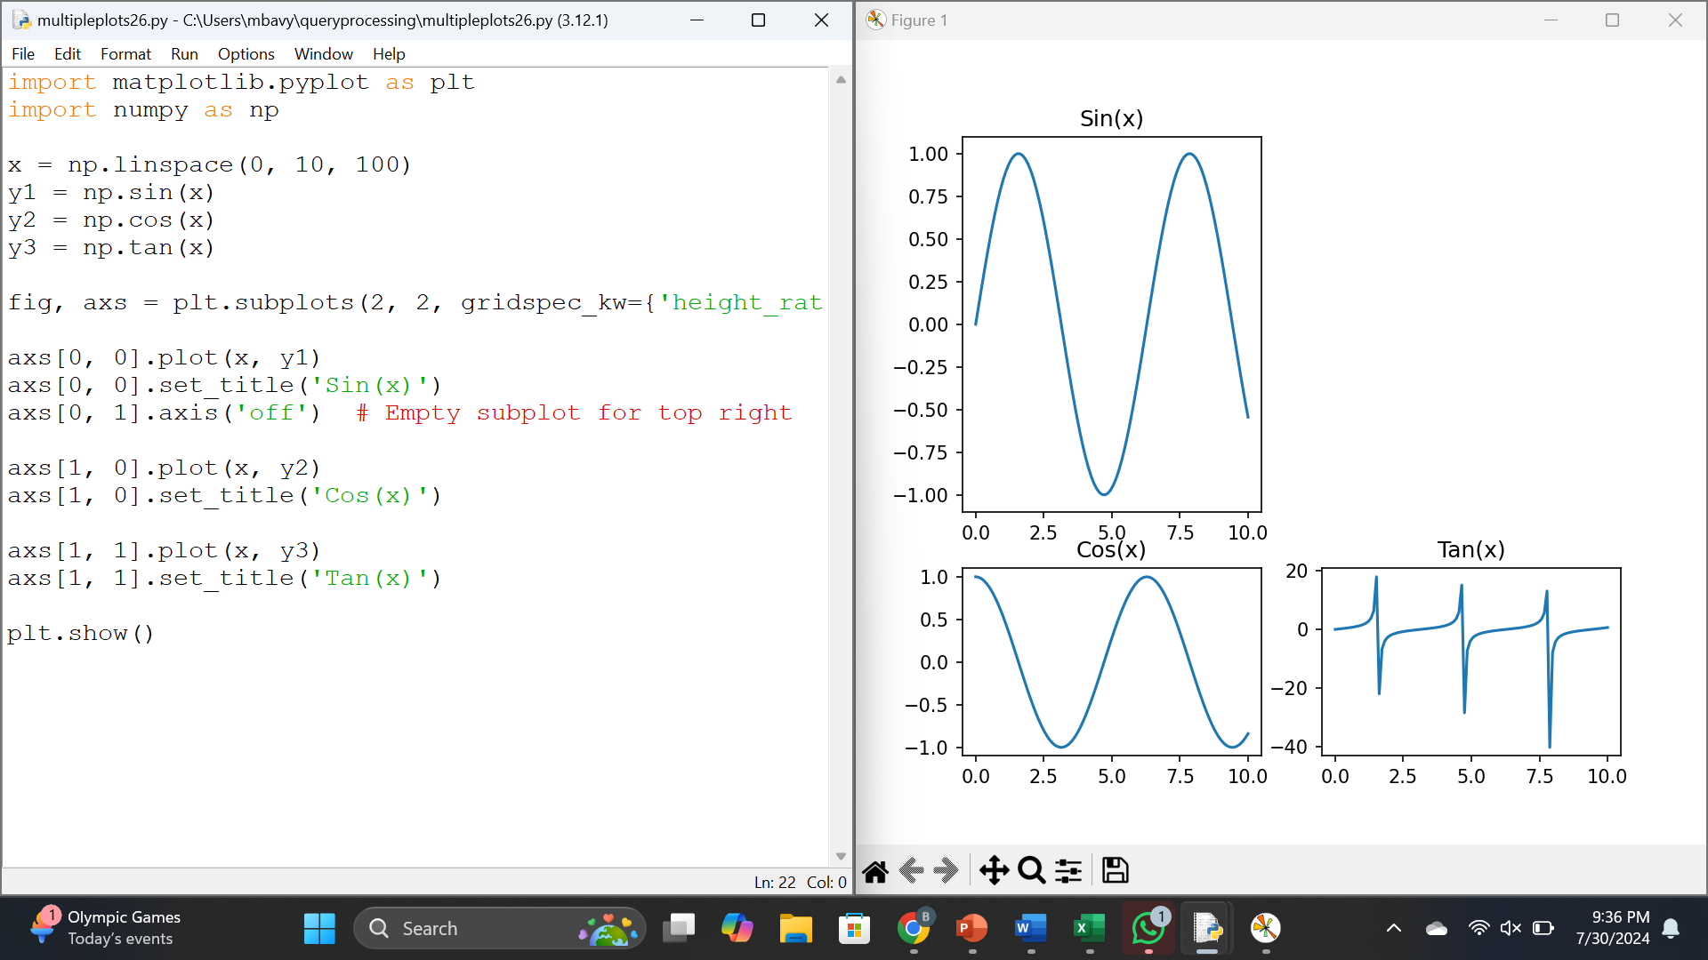

Results :

Thus a Python program to create multiple plots.

Experiment 27

Aim:

To Write a Python programming to display a bar chart of the popularity of programming Languages.

Code :

import matplotlib.pyplot as plt

# Sample data

languages = ['Java', 'Python', 'PHP', 'JavaScript', 'C#', 'C++']

popularity = [22.2, 17.6, 8.8, 8, 7.7, 6.7]

# Create a bar chart

plt.figure(figsize=(10, 6))

plt.bar(languages, popularity, color='skyblue')

# Add titles and labels

plt.title('Popularity of Programming Languages')

plt.xlabel('Programming Languages')

plt.ylabel('Popularity (%)')

# Display the chart

plt.show()

Output:

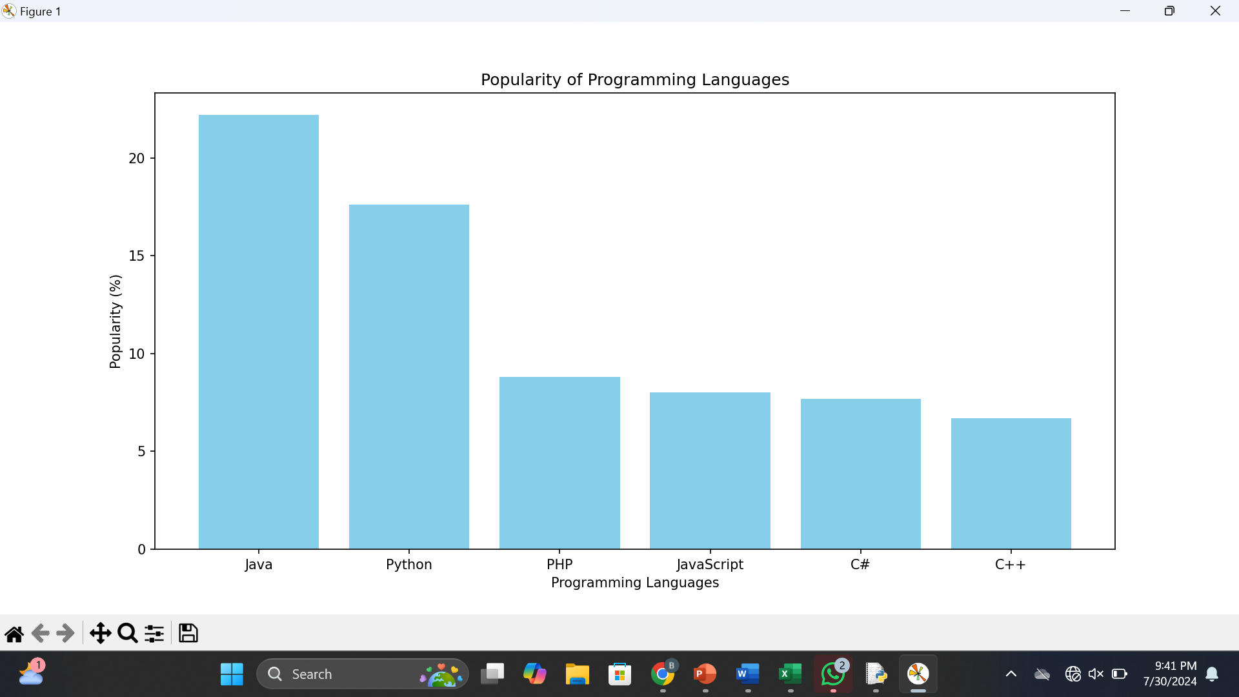

Results :

Thus a Python programming to display a bar chart of the popularity of programming Languages.

Experiment 28

Aim:

To Write a Python programming to display a horizontal bar chart of the popularity of programming Languages.

Code :

import matplotlib.pyplot as plt

# Sample data

languages = ['Java', 'Python', 'PHP', 'JavaScript', 'C#', 'C++']

popularity = [22.2, 17.6, 8.8, 8, 7.7, 6.7]

# Create a horizontal bar chart

plt.figure(figsize=(10, 6))

plt.barh(languages, popularity, color='skyblue')

# Add titles and labels

plt.title('Popularity of Programming Languages')

plt.xlabel('Popularity (%)')

plt.ylabel('Programming Languages')

# Display the chart

plt.show()

Output:

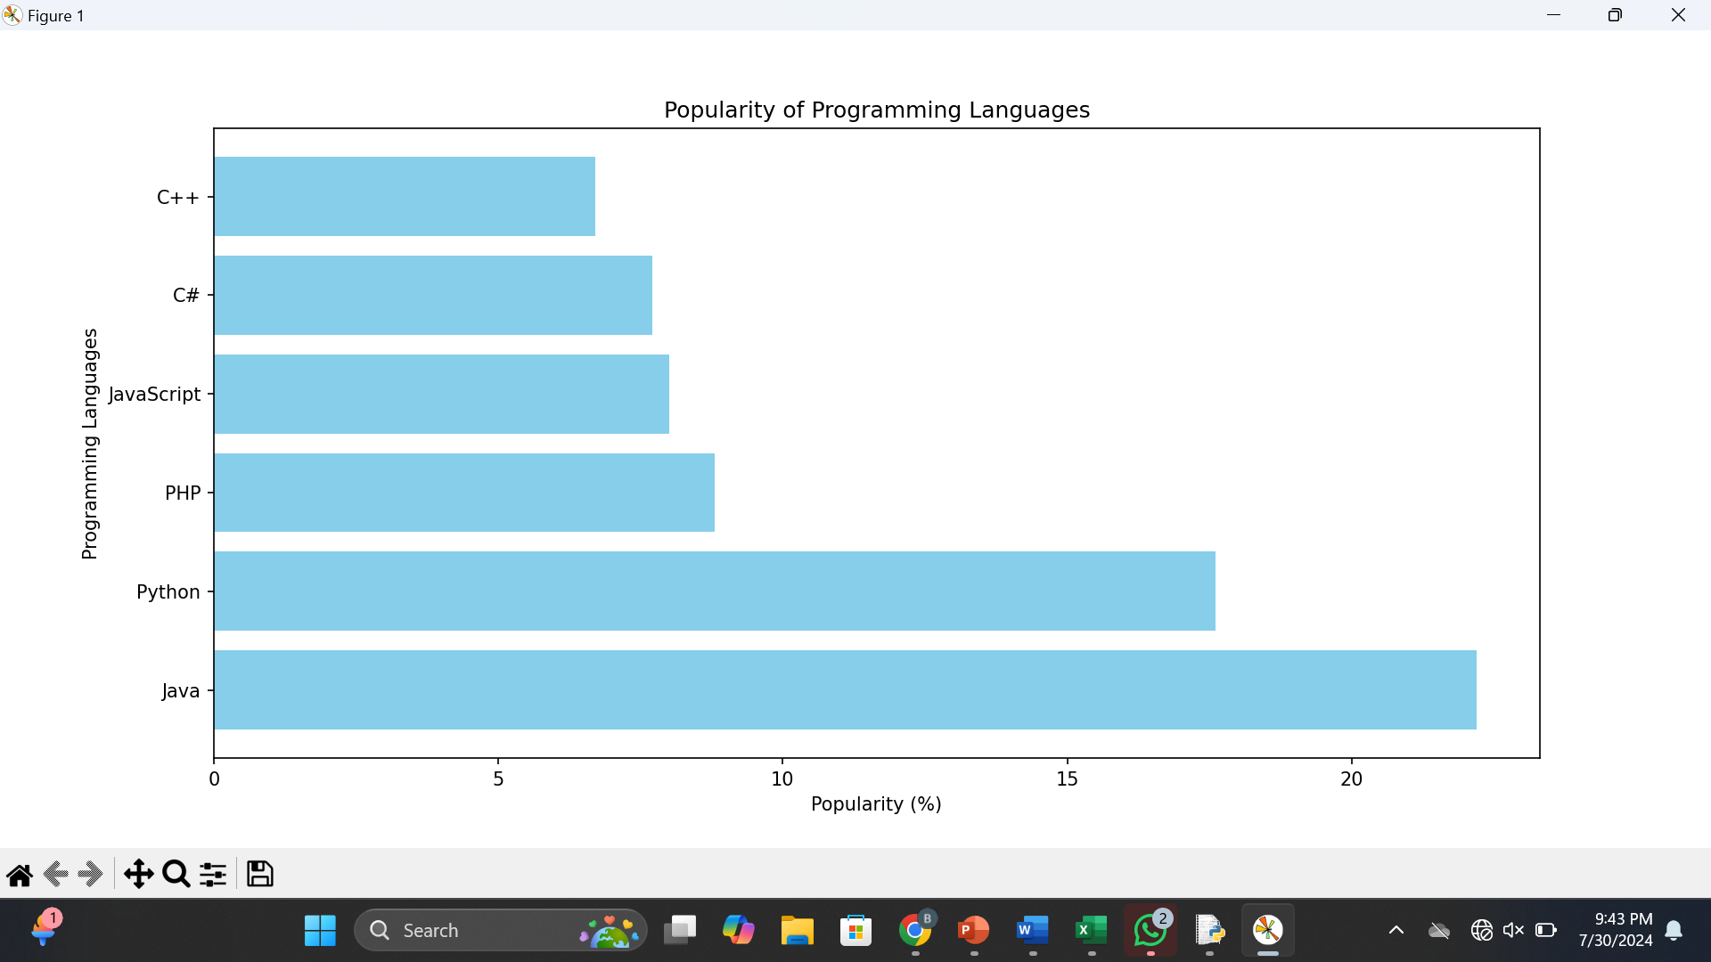

Results :

Thus a Python programming to display a horizontal bar chart of the popularity of programming Languages.

Experiment 29

Aim: To Write a Python programming to display a bar chart of the popularity of programming Languages. Use different color for each bar.

Code :

import matplotlib.pyplot as plt

# Sample data

languages = ['Java', 'Python', 'PHP', 'JavaScript', 'C#', 'C++']

popularity = [22.2, 17.6, 8.8, 8.0, 7.7, 6.7]

# Colors for each bar

colors = ['grey', 'lightgreen', 'skyblue', 'cyan', 'lavender', 'pink']

# Create the bar chart

plt.figure(figsize=(10, 6))

plt.bar(languages, popularity, color=colors)

# Add title and labels

plt.title('Popularity of Programming Languages')

plt.xlabel('Programming Languages')

plt.ylabel('Popularity (%)')

# Display the chart

plt.show()

Output:

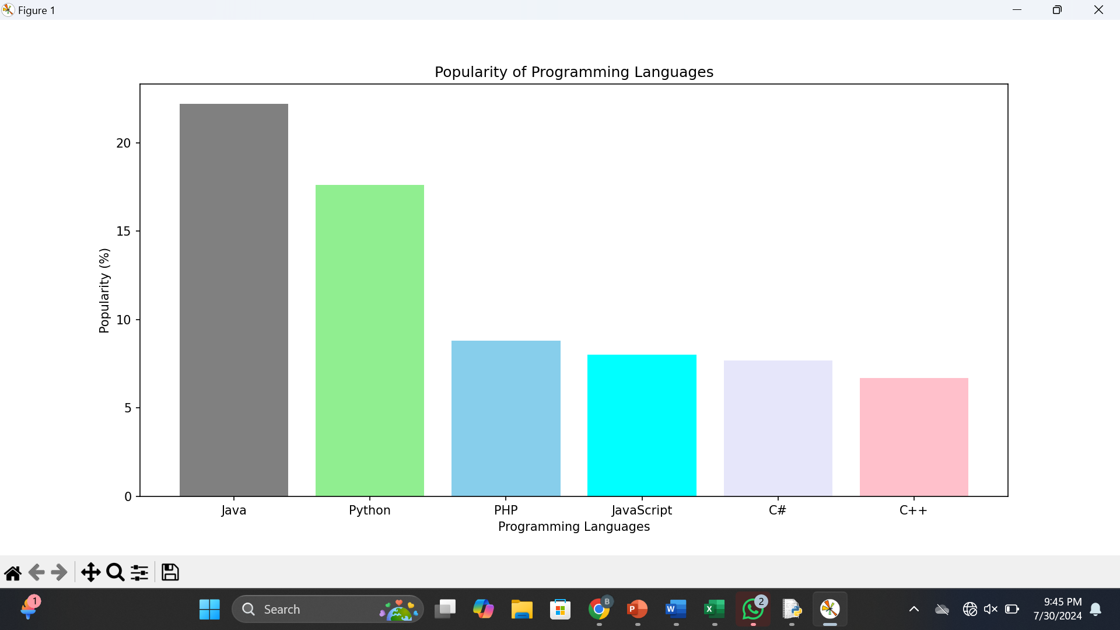

Results : Thus a Python programming to display a bar chart of the popularity of programming Languages. Use different color for each bar.

Experiment 30

Aim:

To Write a Python program to create bar plot of scores by group and gender. Use multiple X values on the same chart for men and women.

Code

import seaborn as sns

t(id_vars='Group', var_name='Gender', value_name='Score')

# Plotting

plt.figure(figsize=(10, 6))

sns.barplot(data=df_melted, x='Group', y='Score', hue='Gender')

# Adding labels and title

plt.xlabel('Groups')

plt.ylabel('Scores')

plt.title('Scores by Group and Gender')

# Show plot

plt.tight_layout()

plt.show()

Output:

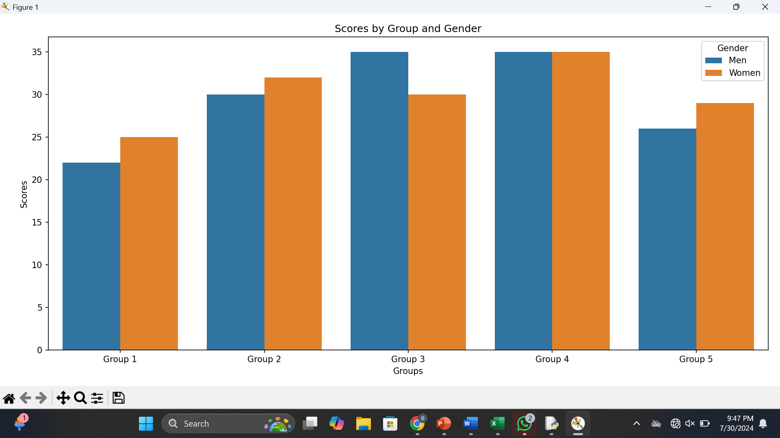

Results :

Thus a Python program to create bar plot of scores by group and gender. Use multiple X values on the same chart for men and women.

Experiment 31

Aim:

To Write a Python program to create a stacked bar plot with error bars.

Code :

import matplotlib.pyplot as plt

import numpy as np

# Sample data

means_men = [22, 30, 35, 35, 26]

means_women = [25, 32, 30, 35, 29]

std_men = [4, 3, 4, 1, 5]

std_women = [3, 5, 2, 3, 3]

# Number of groups

N = len(means_men)

ind = np.arange(N) # the x locations for the groups

# Plot bars for men

plt.bar(ind, means_men, color='skyblue', label='Men', yerr=std_men)

# Plot bars for women, stacked on top of men

plt.bar(ind, means_women, bottom=means_men, color='cyan', label='Women', yerr=std_women)

# Add some text for labels, title and axes ticks

plt.ylabel('Scores')

plt.title('Scores by group and gender')

plt.xticks(ind, ('Group1', 'Group2', 'Group3', 'Group4', 'Group5'))

plt.legend()

# Display plot

plt.tight_layout()

plt.show()

Output:

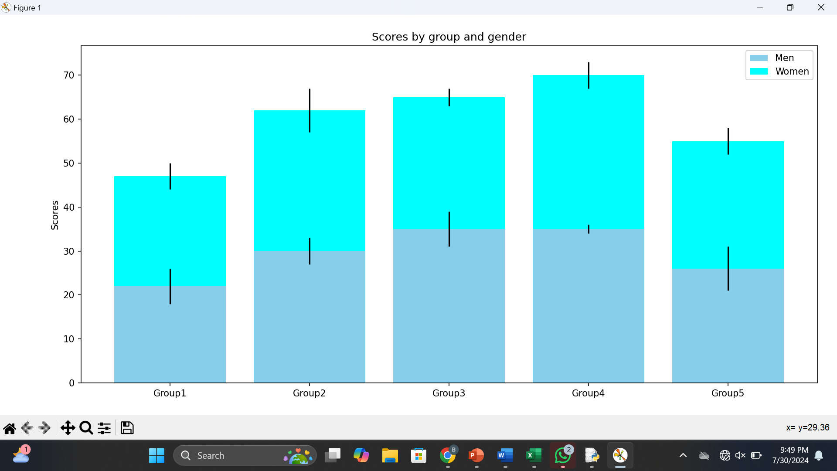

Results :

Thus a Python program to create a stacked bar plot with error bars

Experiment 32

Aim:

To Write a Python program to draw a scatter graph taking a random distribution in X and Y and plotted against each other.

Code

import numpy as np

import matplotlib.pyplot as plt

# Generate random data

# For reproducibility

x = np.random.rand(100) # 100 random values for X

y = np.random.rand(100) # 100 random values for Y

# Create a scatter plot

plt.figure(figsize=(8, 6))

plt.scatter(x, y, color='blue', alpha=0.3, edgecolors='red')

plt.title('Scatter Plot of Random Data')

plt.xlabel('X values')

plt.ylabel('Y values')

plt.grid(True)

plt.show()

Output:

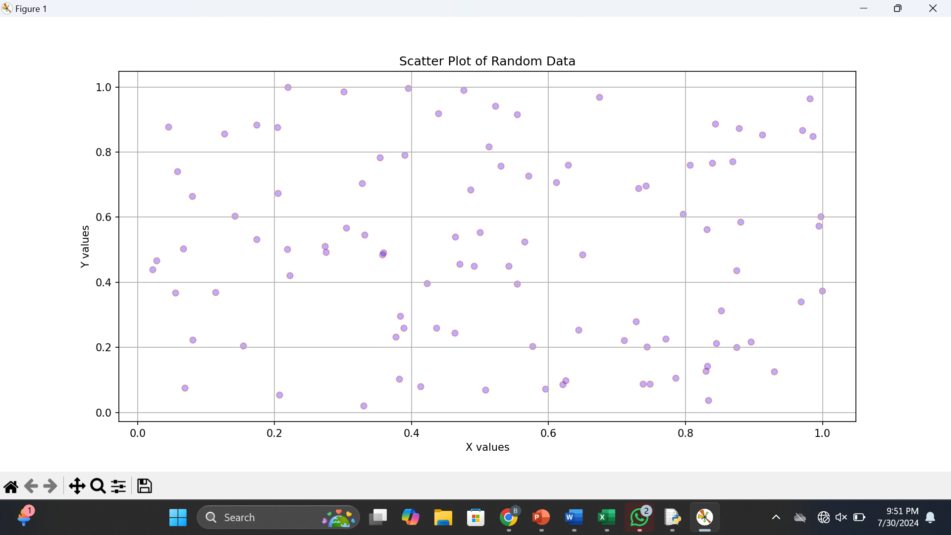

Results :

Thus a Python program to draw a scatter graph taking a random distribution in X and Y and plotted against each other.